Hot New Release!!
Valckenberg Madonna Riesling Kabinett

Madonna – The first actual Wine Brand of Germany, and after well over 100 years of being enjoyed by millions each year, we are able to have more of their wines available in Kentucky… This is the first offering of many from this legendary brand. After all, they are the creators and founders of Liebfraumilch (translation – “Mother’s Milk”). When thousands each month would come to the Abbey for service as well as a “healthy” serving of wine at the courtyard center where the Madonna and Child statue served as the gathering point, “Mother’s milk” was what the gathers called it… Liebfraulmilch.

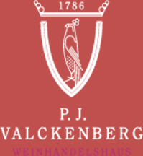

P.J. VALCKENBERG WEINHANDELSHAUS

Wine expertise since 1786

Kabinett is the first of the six subcategories of quality wines with Prädikat. These wines are therefore usually the lightest and driest of the Prädikat wines. They come from fully ripe grapes. The greater ripeness of the grapes and the slightly higher sweetness compared to MADONNA QbA add to the wine’s expressive fruitiness, intensive floral bouquet and underlying herbal character. The delicate sweetness together with a rather mild acidity make this wine an ideal companion for dinner and a wide variety of foods.

